ROI
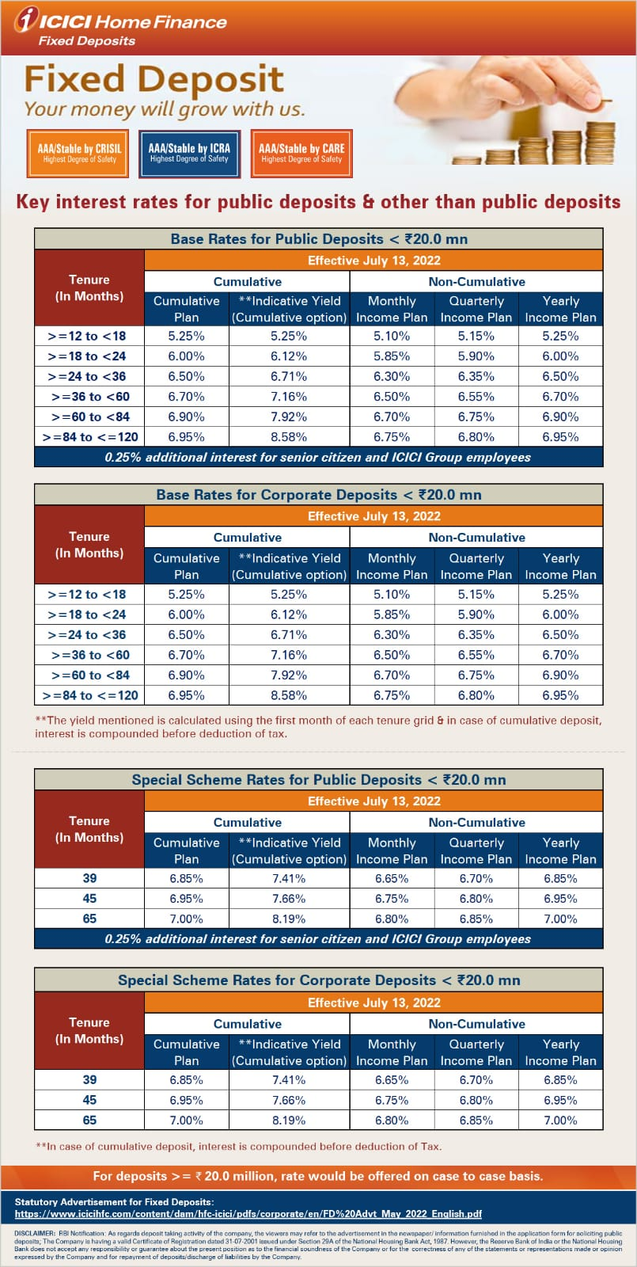

Process note:
COMPANY NAME | CHEQUE IN FAVOUR OF | BANK A/C NO. | IIFL CODE | Branches to Dispatch / Handover the Applications | Where to Deposit | Documents
ICICI HOME FINANCE LTD. | ICICI HOME FIN-FD A/C 000405070754 | ICICI BANK | IIFL Securities Limited | cheque at par/dd payable at mumbai | ICICI HOME FINANCE LTD | Pancard, Address proof, Cancel Cheque and photograph of all applicants on KYC Forms - Self Attested Documents & IIFL RM/Employee OSV Required
 |  | ICICI HOME FIN-FD A/C | C110408 | cheque & application to be sent to ICICI Home Finance Ltd | Unit 101 to 106, Corporate Centre, Andheri Kurla Road,
 |  | A/C NO - 000405070754 |  |  | J. B. Nagar, Andheri - East, Mumbai - 400059

