ROI

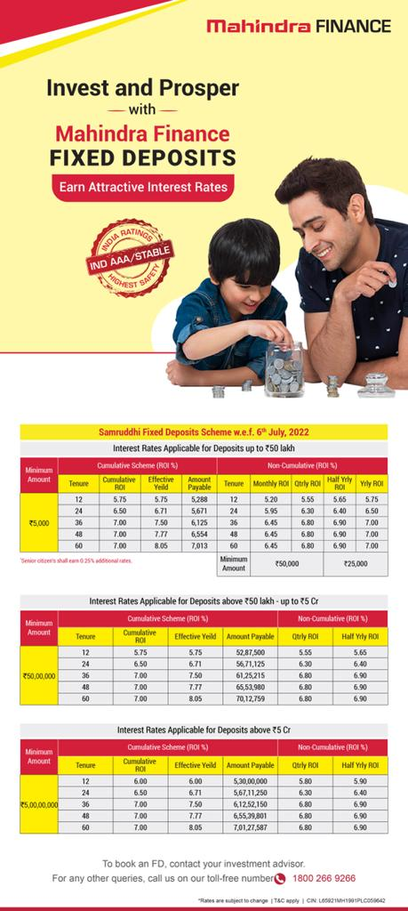

COMPANY NAME | CHEQUE IN FAVOR OF | BANK A/C | IIFL CODE | BRANCHES TO DISPATCH | WHERE TO DEPOSIT | PRINCIPAL BROKER | DOCUMENTS | REGISTER
Mahindra & Mahindra Finance - Individual Deposits | MMFSL - FIXED DEPOSIT | GENERATE CMS SLIP ONLINE thru E-SARATHI PORTAL after doing entries | IIFL Securities Limited | Application & Cheque Deposit Slip Submited on MMFSL Company | To the Company | IIFL - Direct | Pancard, Address proof, Cancel Cheque and photograph of all applicants - Self Attested Documents | Mahindra & Mahindra Financial Services Ltd.
 |  | Cheque along with CMS Slip to br submitted to HDFC Fort branch | BROKER CODE – 100320 |  |  |  |  | Sadhana House, 2nd Floor, Behind Mahindra Tower,
 |  |  |  |  |  |  |  | 570, P. B. Marg, Worli, Mumbai - 400018

