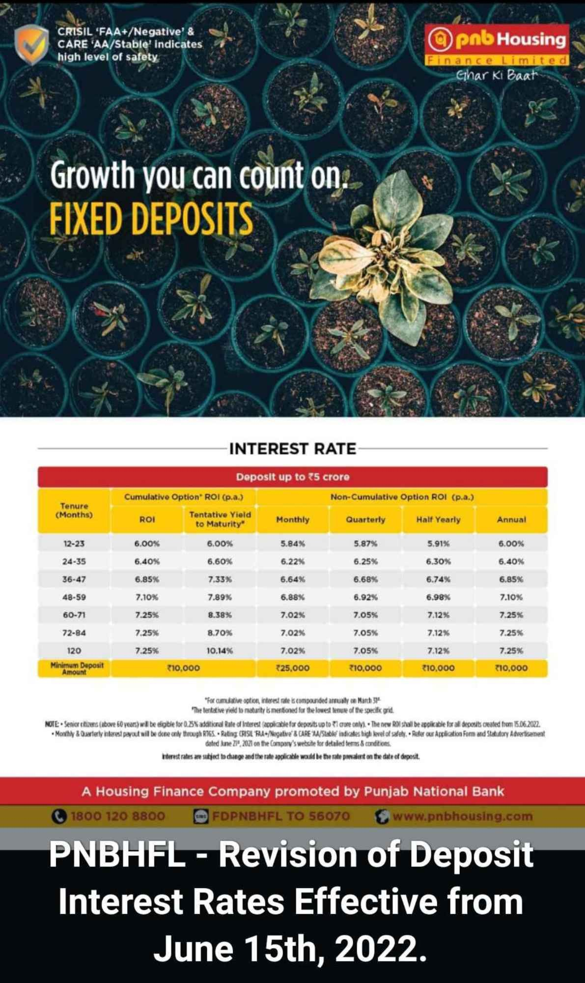
Process Note :

Please find the below process and documentation list required for deposit placement with PNB Housing.

- Hard copy of application form along with physical application form and KYC documents need to be submitted with PNBHFL Branch within 3 days of fund transfer/ cheque submission.
- All KYC documents need to be self-attested by the deposit holder / authorized signatories.
- Cheque / RTGS / NEFT needs to be done in the below mentioned bank account.
- Copy of cheque along with deposit slip is required which has been deposited in bank.
- Third party cheque/payment is not acceptable.
- Documents list is mentioned below for Individual / Trust and Corporate category of investors.
- Correction and Whitener on application is not allowed.

Branch Address to submit application forms.

Address
Samir Sanghvi / Paresh Vedpathak
PNB Housing Finance Ltd.
Office No 4,5,6 Ground Floor, wadia Bldg,
Dalal Street, Opp BSE gate no 2
Fort ,Mumbai 400001

Documents for Individuals

- Application Form duly signed with all deposit holders.
- Photograph with cross signature of all deposit holders.
- I’d and Address proof required with duly signed of all deposit holders.
- Aadhar Card, Driving Licence, Passport, Voter Id. Will be consider as address proof.
- Bank Statement will not be considered as address proof in case of Individual Deposit.

Documents For Corporate Deposits

- Corporate FD application form - Photograph of authorised signatories Sign and Stamp.
- MOA /AOA - sign and stamp.
- Certificate of incorporation - sign and stamp.
- Company pan card - sign and stamp.
- company address proof - sign and stamp.
- Board resolution copy - sign and stamp.
- List of Directors - sign and stamp.
- KYC of director's ( photo , Pan card, Aadhaar Card) - self sign on kyc.
- Cheque “ PNB Housing Finance Ltd” / if RTGS / NEFT transfer then cancelled cheque copy required.

Documents For Trust Deposits

- FD application form – Sign and Stamp - Retail Application.
- Trust Deed copy – Sign and Stamp
- Trust Pan card copy – Sign and Stamp
- Trust address proof – Sign and Stamp ( for bank statement required latest 3 months).
- Board resolution on trust letter head – Sign and stamp ( all trustees )
- List of trustees on trust letter head - Sign and stamp ( all trustees )
- KYC of trustees – Sign - pan card , Aadhar card.
- Photos of trustees
- Cheque “ PNB Housing Finance Ltd” / if RTGS / NEFT transfer then cancelled cheque copy required.

- All the above documents should be self-sign with stamp.

Bank Details For RTGS / NEFT and deposit of cheque

Please find below bank details for PNB Housing Finance Ltd for RTGS & NEFT Payments.

Name of Bank – HDFC Bank Ltd – New Delhi Dwarka Branch
Beneficiary Name – PNB Housing Finance Ltd
Type of Account – Current Account
Account No – 57500000413104
IFSC Code – HDFC0000249

Branch | Account number | Account Title | IFSC Code
Delhi /Mumbai | 57500000413104 | PNB Housing Finance Limited | HDFC0000249

Kindly provide the clients details with UTR Number with date once payment is done and send all documents and application at Fort Branch.

Contact Details of concern person in PNB Housing Finance Mumbai

Name | Designation | Contact details | Email id
Samir Sanghvi | Relationship Manager | 9833710167 | samir.sanghvi@phfl.com
Paresh Vedpathak | Customer Service Support | 8657532084 | Paresh.vedpathak@pnbhousing.com
Vishal Bhimjiyani | Regional Manager | 7738160480 | Vishal.bhimjiyani@pnbhousing.com

